**DAILY ONLINE ACTIVITIES SUMMARY**

|  |  |  |  |  |  |  |  |  |
| --- | --- | --- | --- | --- | --- | --- | --- | --- |
| **Date:** | **23/06/2020** | | | | | **Name:** | **ASHISH GRACION MENEZES** | |
| **Sem & Sec** | **4&A** | | | | | **USN:** | **4AL18CS012** | |
| **Online Test Summary** | | | | | | | | |
| **Subject** | | **N/A** | | | | | | |
| **Max. Marks** | | **N/A** | | **Score** | | | **N/A** | |
| **Certification Course Summary** | | | | | | | | |
| **Course** | **MICROSOFT AZURE ESSENTIALS** | | | | | | | |
| **Certificate Provider** | | | **Great Learning** | | **Duration** | | | **12 hours** |
| **Coding Challenges** | | | | | | | | |
| **Problem Statement1:Write a java program to find modular exponentiation** | | | | | | | | |
| **Status:Executed** | | | | | | | | |
| **Uploaded the report in Github** | | | | | **YES** | | | |
| **If yes Repository name** | | | | | **https://github.com/ash7745/lockdown-coding** | | | |
| **Uploaded the report in slack** | | | | | **YES** | | | |

Online Test Details1: N/A

Certification Course Details: MICROSOFT AZURE ESSENTIALS(continuation)

Today I have completed 1 module which is of duration 2.5 hours out of which I have completed watching 2 hours of video content.

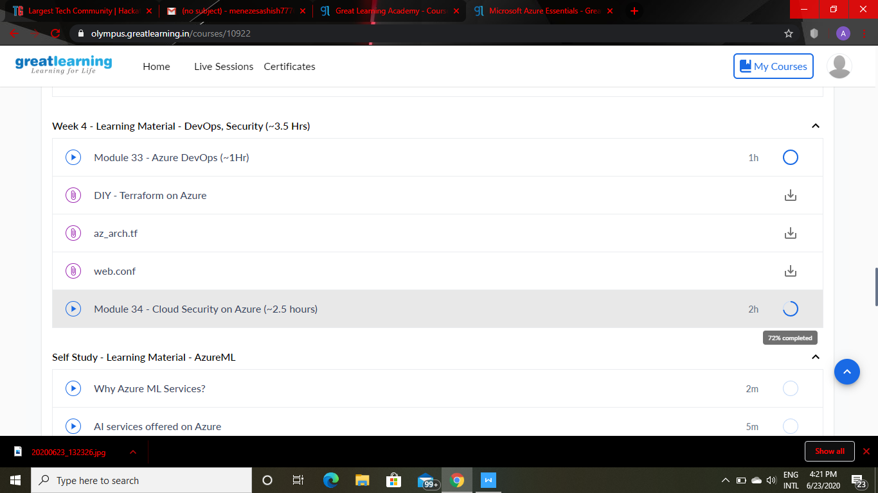

Webinar details: Webinar on IOT

Attended a webinar on IOT which was organized by AIET and the webinar was conducted by Prof.Sushanth M .The duration of the webinar was nearly 1.5 hours. A quiz was conducted on the particular topic.The duration of the quiz was 20 mins(4 pm to 4:20 pm).The questions were of MCQ type.

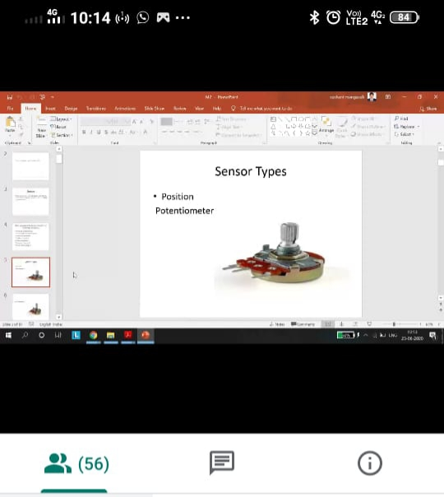

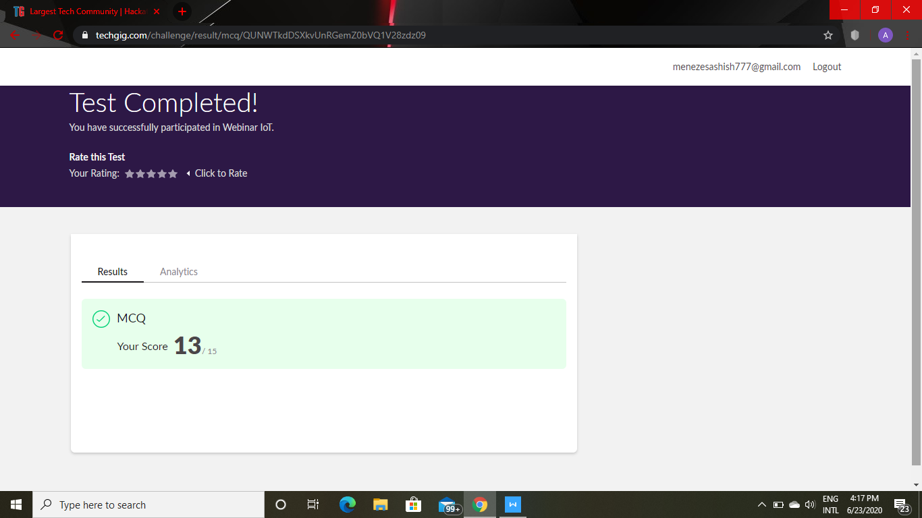

CODING DETAILS: Write a java program to find Modular Exponentiation

